AUTH-005
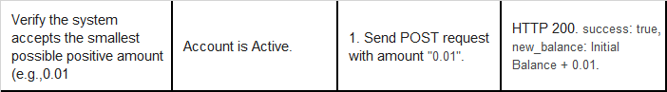
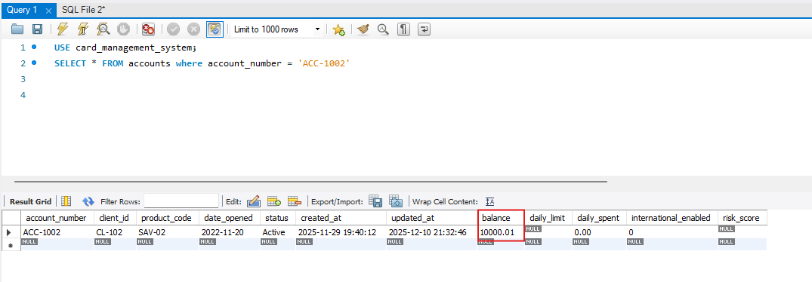
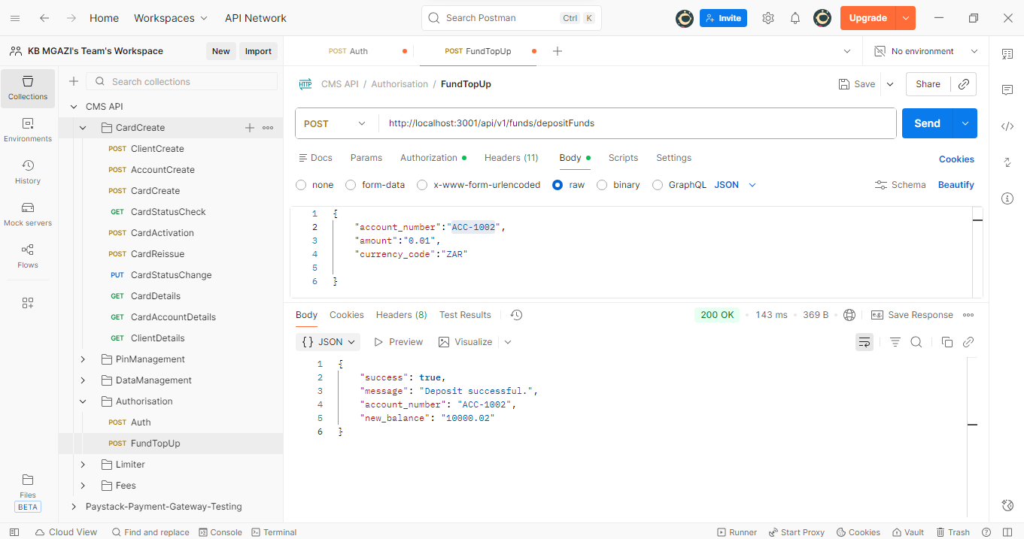
Request:
{
"account_number":"ACC-1002",
"amount":"0.01",
"currency_code":"ZAR"

}
Response:
{
"success": true,
"message": "Deposit successful.",
"account_number": "ACC-1002",
"new_balance": "10000.02"
}
